**ENGR 110: Bright Ideas: Photovoltaic panels and Solar Power**

**Username: leoanelge**

**Name: Elgene Menon Leo Anthony**

**Id:300492604**

SAFETY NOTES:

1. in the following, bear in mind that incandescent lamps get very hot and you cannot touch the bulb until it has been off for quite a while.
2. Our solar panels are very low voltage (a few Volts). But higher voltage solar panels can easily electrocute a person.
3. Note also resistors can get very hot if they carry too much current. They can smoke and burn.
4. The motor is to be connected ONLY to the solar panel. Do not connect it to a power supply .



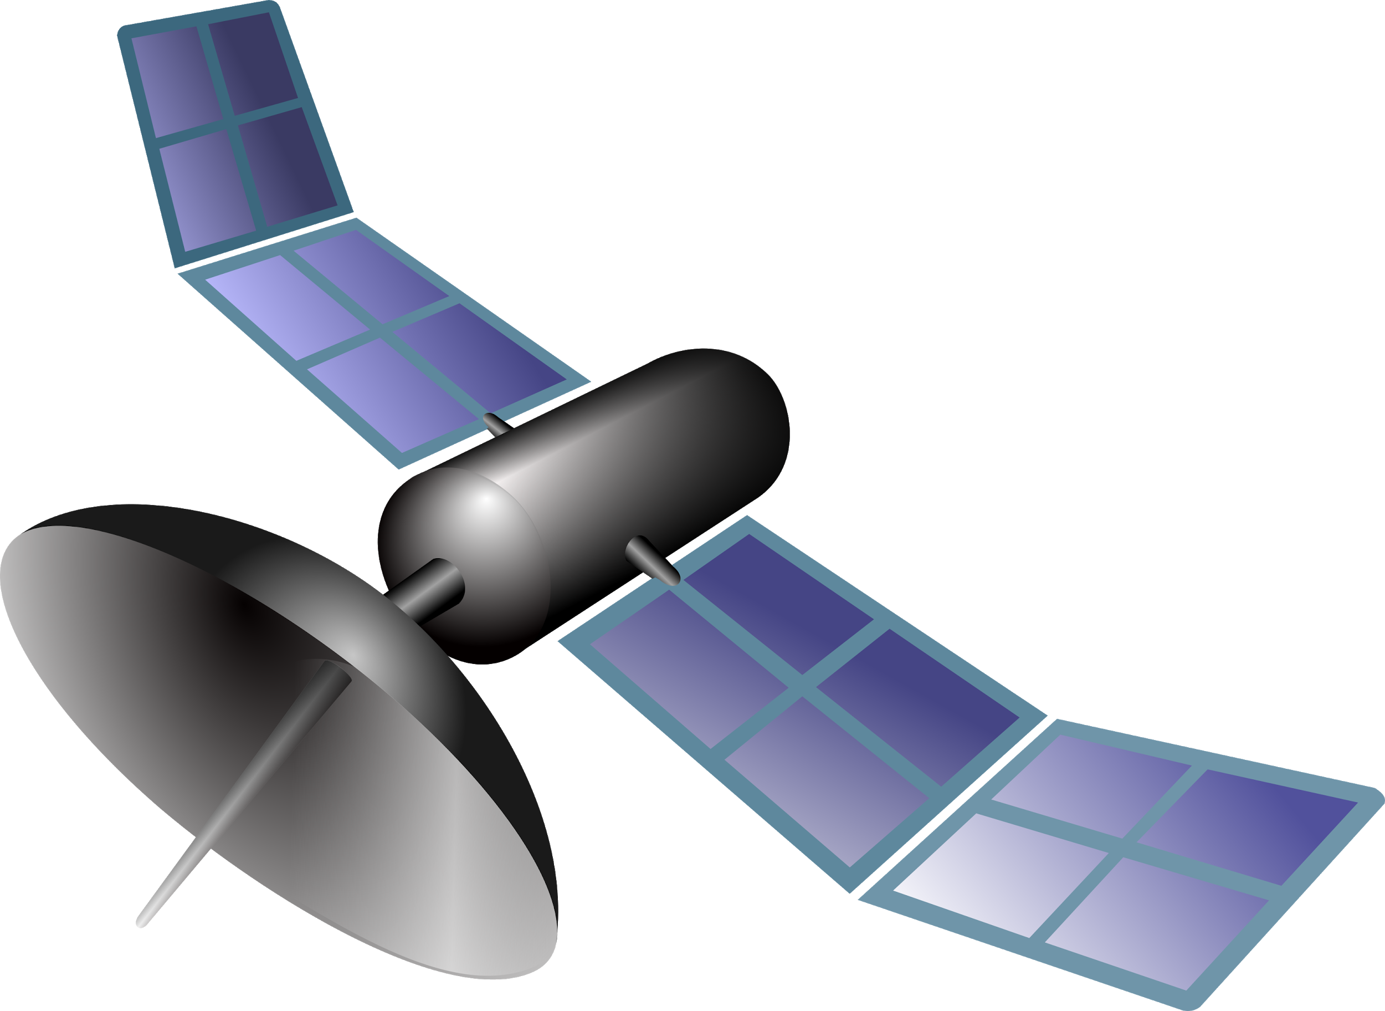

**Introduction**We use electricity constantly for countless purposes, and recent developments in battery and motor technology are expanding the range of electrical technology. For example, affordable and practical electric cars, once the stuff of science fiction, are rapidly becoming mainstream. Some experts argue that self-driving, electric cars may largely replace human-driving, petrol and diesel vehicles within a few decades or even soon[1]. In general, electric energy is essentially an *energy currency* that can be used for nearly anything.

We seem to be on the cusp of a major technological revolution in the ways electrical energy is used, and in parallel, a revolution in the way electrical energy is produced and transmitted. The “old” way of making most electricity consisted of burning some sort of fuel and using the energy to run an engine. The engine would then spin a magnet in a coil and produce electricity. Electric energy production in NZ developed in a different way, using mostly hydroelectric plants in which falling water provides the energy to spin magnets in coils[2]. in both cases the power plants were and mostly still are very large-scale facilities often far from the end user. Now wind generators and solar energy are rapidly expanding. They are often smaller scale facilities coupled to a “smart grid” that can distribute electric energy produced in a wide range of methods to a very complex set of loads (users). Photovoltaics or solar panels are semiconductor devices, usually made of silicon, which convert light energy to electrical energy. At present they produce a small but rapidly increasing share of the world’s electricity[3]. Photovoltaics have dropped rapidly in price in recent years[4]. While they were previously used in remote locations, far from the grid, commercial installations that feed the grid are now becoming widespread. We will learn a bit about these devices in this lab and in parallel tutorials.

**CORE: Getting Started**

CORE 1: (10 marks)

We will use angle poise lamps with 60 W incandescent light bulbs to simulate the sun. Connect your solar panel to the fan, place the lamp about 15 cm above the solar panel, and turn on the lamp. Be sure the solar panel faces the lamp directly. Watch the motor spin! Then use your two meters to measure the voltage and current delivered to the motor and thus calculate the power. Note: Use the Fluke DMM (digital multimeter) as the ammeter. The other meters have a larger internal resistance than the Fluke and are not suitable for measuring current in this lab exercise.

**************************************************************************************

current = 0.035A

Voltage = 0.84 V

P = IV or P = V2 /R or P = I2 /R

P = 0.035A*0.84

= 0.029 Watts

**************************************************************************************

CORE 2 (10 marks)

Your solar panel has three separate sections. These each produce 1.5 volts, and they can be connected in series or parallel. Make a diagram of the three sub panels connected in series and another in parallel and discuss the differences. Our motor draws quite a lot of current but can run on a small voltage. Should use use series or parallel? Flip the solar panel over and see how it is connected. Is it what you expected? Note: the motor will not spin if you use the other arrangement.

**************************************************************************************

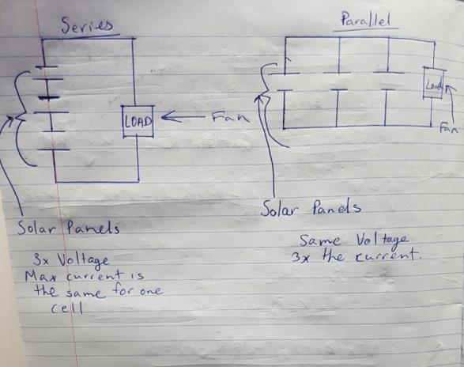

The series circuit has the same current going throughout the circuit such as (I1 = I2 = I 3 =current) and the voltages add up (v1 +v2 +v3=Voltage).

The parallel circuit works the opposite to the series circuit which means the current is add up (I1 + I2 + I3=current) and the voltage is the same for all (V1 = V2 = V3= Voltage).

Therefore, this involve high current and pretty low voltage. In order to get more current and not the voltage. The parallel circuit is suitable for these subpanels.

**************************************************************************************

CORE 3: (5 marks)

What does intensity of light mean? What are the units of intensity?

**************************************************************************************

The intensity of light is the energy of light produced. The unit of intensity is W/m^2 per unit area per second

**************************************************************************************

CORE 4: (5 marks)

Write a formula for the intensity of light a distance *R* from a small (point) light source.

**************************************************************************************

I = P/4πr2

I = Intensity, P= Power, 4π = surface area of sphere, r2= distance of sphere (light source) which are round.

**************************************************************************************

CORE 5: (5 marks)

Based on your formula, what would happen to the intensity of light if the distance between the solar panel and the “sun” was reduced from 15 cm to 7.5 cm? What would happen to the power delivered? Make a prediction.

**************************************************************************************

If the distance between the solar panel and the lamp was reduced in half the distance, the power might deliver about four times more the amount.

**************************************************************************************

CORE 6: (10 marks)

Test your prediction. Use the motor as a load. If you prediction was incorrect, explain where your reasoning went wrong. If your prediction was approximately correct explain where measurement errors may have arisen. **Solar panels lose efficiency as they warm. So after you finish your measurements, move your lamp back to 30 cm to avoid warming your solar panel as the output of the solar panel will vary with temperature.**

********************************************************************************

Power at 15 cm: 0.029W

Power at 7.5 cm: P = VI

V = 1.12V, I = 0.051A

P = 1.12 x 0.051 = 0.057W

Theoretically, the power at 7.5 cm would be four times more that of the power at 15 cm. However, the result shows power is double the amount. This is possibly because there is for a point source of light rather than a bulb. The geometry of the surface area will have changed the results and thus not match the theoretical result.

******************************************************************************************

**It’s Complicated**

You will be unsurprised to learn that there are complications with solar panels. We will explore two of them: angle dependence and impedance matching.

CORE 7: (5 marks)

Vary the angle of the solar panel so it does not point directly at the lamp. What happens?

**************************************************************************************

The voltage drops so the power will be less.

**************************************************************************************

**Impedance Matching**

We will discuss “impedance matching” in lecture and lab. We will investigate how it affects the use of solar panels.

Power sources such as a battery or a solar panel can be modelled as an ideal voltage source *V* in series with an internal resistance *r* as in the diagram below. Note that the internal resistance *r* is not a physical resistor. Instead it is a way of modelling the fact that the power source cannot deliver unlimited current and the voltage drops once we start drawing current from it.

In the diagram below the power source is connected to a load *R*. The load is the motor in our case. If the load resistance is very large, then very little current flows and very little power is delivered to the load. On the other hand, if the load resistance is much smaller than the internal resistance of the power source then a large current flow but most of the power is delivered to the internal resistance of the power supply. In an extreme case of a shorted power supply all the power is delivered to the internal resistance. A shorted battery for example gets very hot and can be quite dangerous. There is an optimum load resistance that delivers as much power as possible to the load. In a challenge problem you will show this is when r *= R*, so the load and internal resistances are the same. This is called *resistance matching* or *impedance matching* for circuits with reactive circuit elements (inductors and capacitors).

*R*

*r*

*V*

We can measure the internal resistance of our solar panels just by finding the load resistance that maximizes the power to the load. To do this we will use a various resistors as our load and measure the current and voltage for each resistance. A graph of power versus load resistance then tells us the optimum.

COMPLETION 1: (25 marks)

Make a data table, measure *P* versus *R* so that you see a maximum. Graph your data. What is the internal resistance of your solar panel?

**************************************************************************************

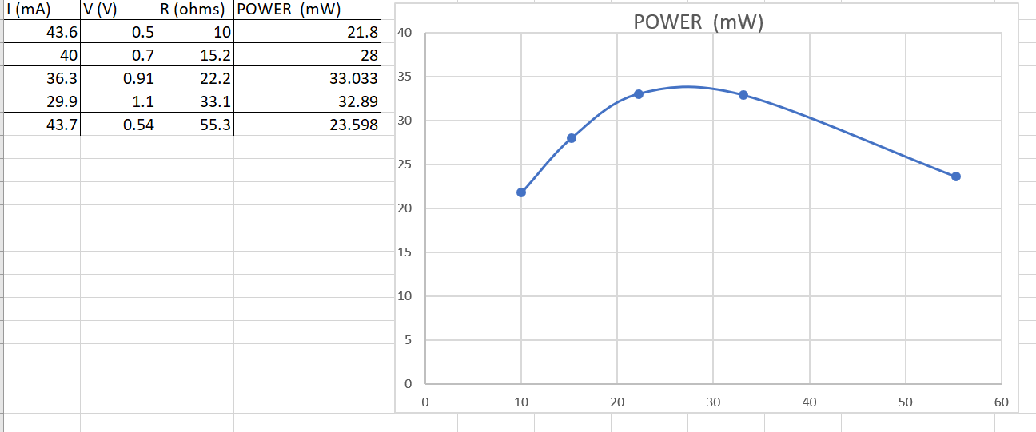

r = 25 ohms

**************************************************************************************

COMPLETION 2: (5 marks)

Check the internal resistance you measured in completion 1 directly by measuring the solar panel voltage with no load and the current when the solar panel is shorted. Note this would be DANGEROUS with a power supply, battery, or larger solar panel. Ours is not capable of delivering large currents and this measurement is safe.

**************************************************************************************

I = 78 mA

V = 1.57 V R = V/I

R = 1.57/0.078 = 20.1 ohms

**************************************************************************************

**It’s even more complicated.**

The internal resistance of a solar panel is not a constant. It depends on the intensity of the light and also on the temperature. For small scale solar panels powering small devices we largely ignore this complication, but for larger commercial applications it needs to be considered and increases the complexity of photovoltaic installations.

**CHALLENGE**

CHALLENGE 1: (5 marks)

Show that *r = R* optimizes the power delivered to the load. Hint: take the derivative with respect to *R*.

**************************************************************************************

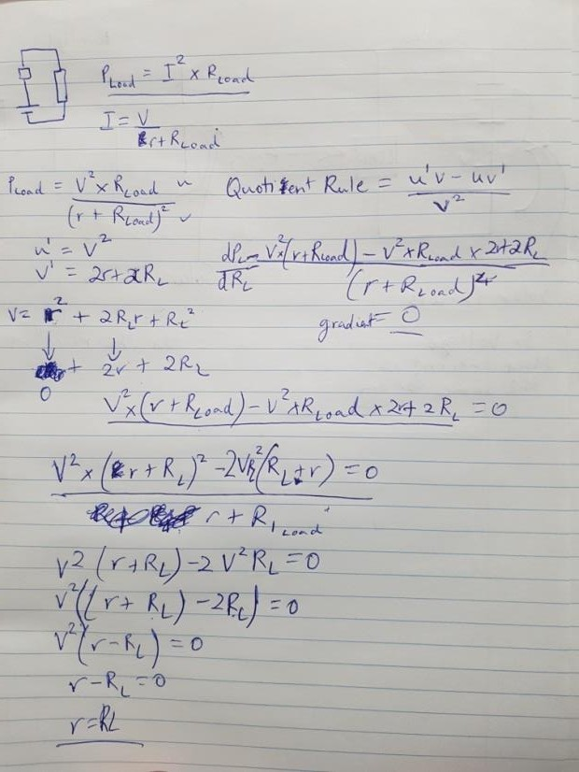

**************************************************************************************

CHALLENGE 2: (5 marks)

It turns out matching impedance is a good way to connect a solar panel to a load but is not a good way to connect a fuel burning generator to a load. Why? Hint: what gets optimized in CHALLENGE 1? Is this what you want to optimize when burning fuel?

**************************************************************************************

For solar power, impedance matching is useful because we only need want the optimising the amount of energy we take from the light.

For a fuel burning generator it is more important to optimize the percentage fuel converted to electric energy.

**************************************************************************************

CHALLENGE 3: (5 marks)

Reminder: in the following, bear in mind that incandescent lamps get very hot and you cannot touch the bulb until it has been off for quite a while. Borrow the fluorescent lamp or LED from a tutor. Illuminate the solar panel connected to the motor with the LED lamp. Nothing happens even though the LED lamp is brighter than the incandescent! Explain this.

**************************************************************************************

Solar panels respond to different wavelengths of light differently – converting some into electricity but ignoring others.

Because the light spectrum of an incandescent bulb it very similar to that of the suns, it can be used with the solar panel.

Even though the LED is brighter, it has a different spectrum of light with wavelengths that do not get converted into electricity in the same way.

**************************************************************************************

CHALLENGE 4: (5 marks)

Is the motor well matched to the solar panel? Explain your reasoning and any measurements you made. Hint: a motor behaves differently when it is running.

**************************************************************************************

No. The motor was fluctuating depending on where the solar panel was placed. If it was too close, the fan would spin at a normal or “fast” speed and when it was at its furthest point, it would be at a slow speed. If it was well matched, the solar panel would be rated for the output current for the motor because the motor draws more current than the solar panel can produce unless placed directly in front of the Incandescent light.

**************************************************************************************

1. For example, see Rethinking Transportation 2020-2030 by Stanford Economist Tony Seba.
2. Electricity generation data for NZ is available from the NZ Government. See for example http://www.mbie.govt.nz/info-services/sectors-industries/energy/electricity-market/electricity-industry/electricity-generation.
3. https://www.eia.gov/outlooks/ieo/electricity.php
4. https://blogs.scientificamerican.com/plugged-in/the-price-of-solar-is-declining-to-unprecedented-lows/